**Chapter 1: Nature of Science in Chemistry**

**All Lectures Uploaded on YouTube:**

[**https://tinyurl.com/fkm9-chemistry**](https://tinyurl.com/fkm9-chemistry)

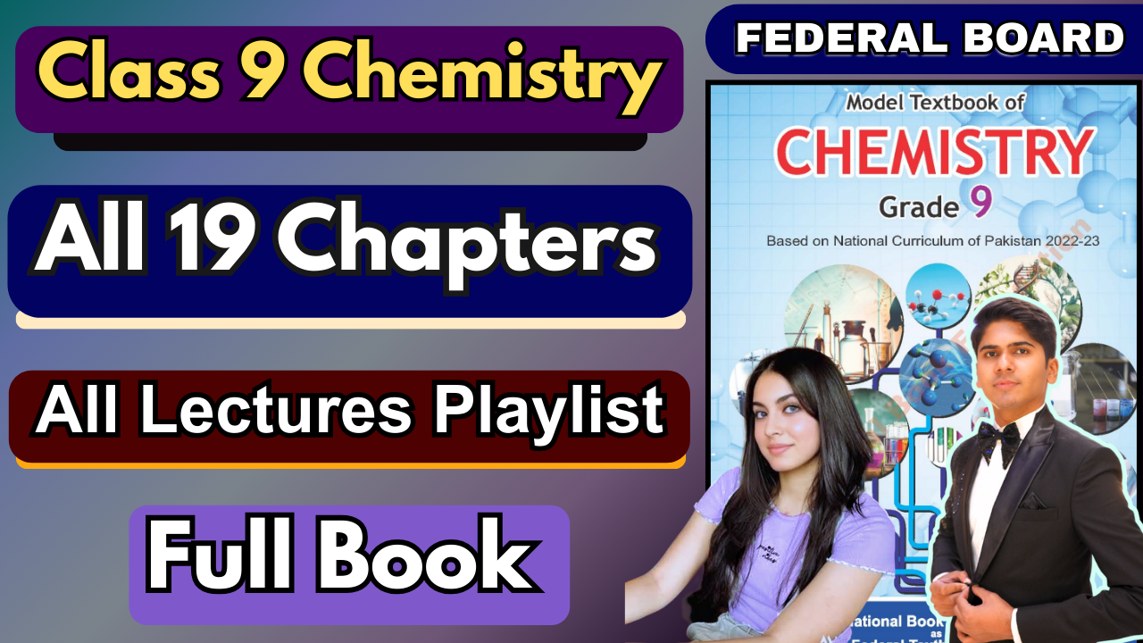

**1.1. What is Chemistry? (The Big Picture)**

Imagine you’re trying to understand how everything around you works. This includes the air you breathe, the food you eat, and even the phone you hold. That’s what Chemistry helps us do!

Think of Chemistry as a special detective science. It helps us figure out:

• What stuff is made of: What are the tiny particles that build everything?

• How stuff behaves: Why does ice melt when it gets warm? Why does wood burn?

• How stuff changes: When you bake a cake, flour, eggs, and sugar turn into something new. Chemistry explains *how* this transformation happens.

• How stuff interacts with energy: For example, how burning wood gives off heat, or how sunlight helps plants grow.

**Why do we study Chemistry?** Because understanding matter helps us do amazing things. We can create new medicines, invent new materials like plastics, and build better technologies.

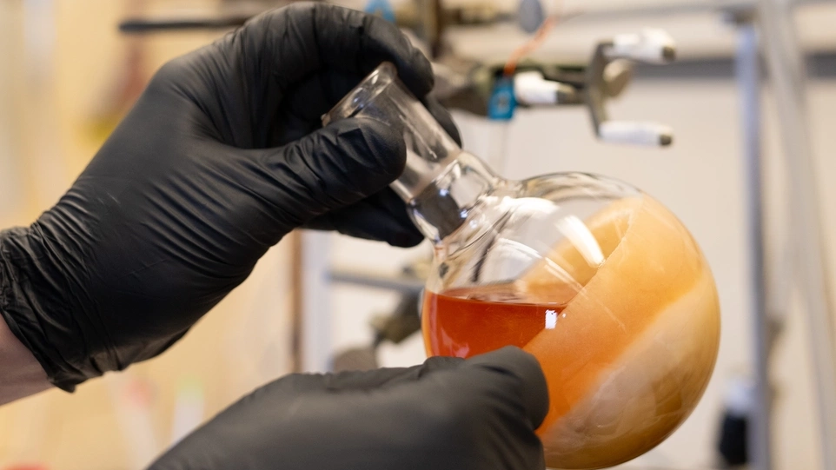

A Special Note on "Green Chemistry"

This is like "eco-friendly" chemistry. It focuses on making chemicals and products in ways that are safer for people and the planet. It aims to reduce pollution and waste. It’s about being smart and responsible with our chemical knowledge to protect the environment.

**1.2. Different "Departments" of Chemistry**

Chemistry is a very broad field. So, it’s divided into smaller areas or "departments." Each department focuses on different types of chemical questions and problems.

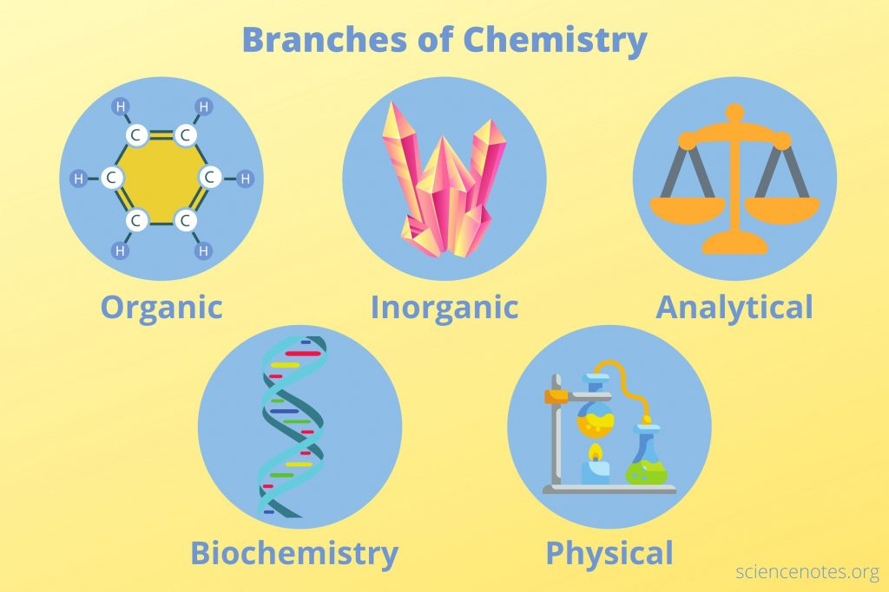

Major Branches

(a) **Organic Chemistry:** This area is very interested in carbon. If a substance contains carbon (and many living things and man-made materials do), an organic chemist will study it. Think of it as the "carbon club."

Simple Idea

Most things from living beings, like your body, as well as fuels and plastics, are studied in organic chemistry.

(b) **Inorganic Chemistry:** This is the "everything else" department! If a substance doesn’t mainly involve carbon, it likely falls under inorganic chemistry. This includes metals, rocks, and many minerals.

Simple Idea

Examples include table salt, iron metal, and the soil beneath your feet.

(c) **Physical Chemistry:** This department connects chemistry with physics. It uses rules and math from physics to explain *why* chemicals act the way they do. It looks at the deep scientific reasons behind chemical reactions.

Simple Idea

Why does water boil at 100 degrees Celsius? How much heat comes out when some thing burns?

(d) **Analytical Chemistry:** This department acts like a "chemical detective" lab. Its main job is to find out: "What is this substance?" and "How much of it is there?" They use special tools to identify unknown chemicals or measure exact amounts.

Simple Idea

Imagine testing water to make sure it’s clean, or checking food for specific ingredients.

(e) **Biochemistry:** This department studies the amazing chemical reactions that happen inside living things. It’s all about the chemistry of life!

Simple Idea

How does your body break down food for energy? How do plants use sunlight to grow? These are questions for biochemistry.

(f) **Environmental Chemistry:** This department looks at how chemicals affect our planet and us. They study pollution, climate change, and how we can protect our environment.

Simple Idea

Why is smog bad for our health? How do farm chemicals affect soil and water?

**More Specialized Branches**

There are even more specialized areas within chemistry:

(g) **Industrial Chemistry:** Focuses on making chemical products on a very large scale for factories and businesses. 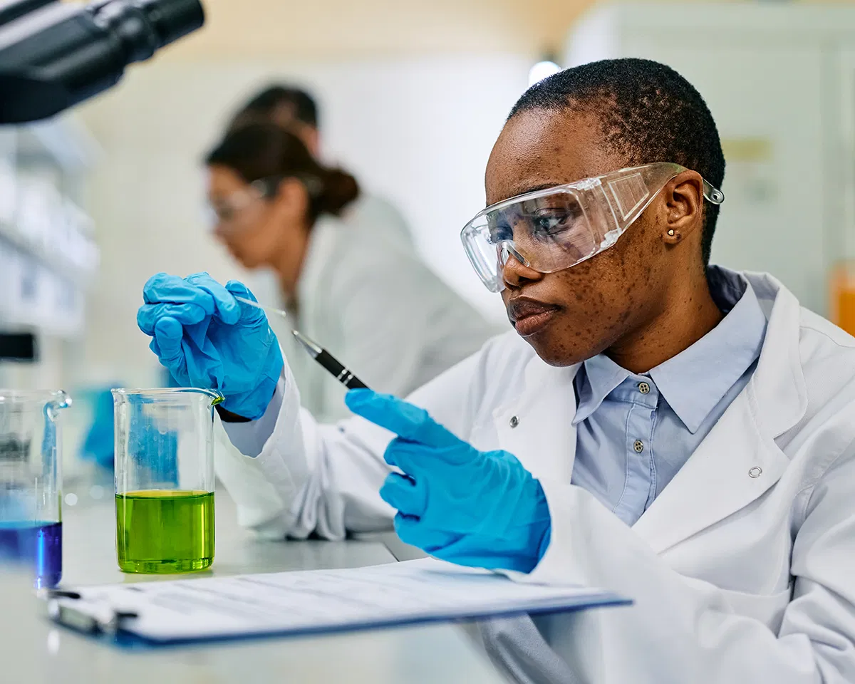

(h) **Medicinal Chemistry**: Works on creating and improving new medicines and understanding how they work in our bodies.

(i) **Polymer Chemistry:** Specializes in "polymers," which are very large molecules made from many small, repeating units. Examples include plastics, rubber, and synthetic fibers.

(j) **Geochemistry:** Studies the chemistry of the Earth itself, including rocks, minerals, soil, and water.

(k) **Nuclear Chemistry:** Deals with changes that happen in the center (nucleus) of atoms, like in nuclear power or radioactive materials.

(l) **Astrochemistry:** Explores chemical processes that occur in outer space, such as on plan ets, stars, and comets.

**1.3. Big Questions Each Chemistry Department Asks**

To understand what each "department" is interested in, let’s look at some key questions they try to answer:

**Physical Chemistry**

• What are the tiniest parts of everything (atoms) made of?

• How do chemicals stick together (form bonds) to create different materials?

**Organic Chemistry**

• Why is carbon so special that it’s in almost all living things?

• How do different arrangements of carbon atoms create totally different substances?

**Inorganic Chemistry**

• What makes non-carbon compounds unique?

• How does the "Periodic Table" (the chart of elements) help us organize all the different building blocks of matter?

**Analytical Chemistry**

• How can we accurately find out what an unknown sample is? How much of a substance is present?

**Biochemistry**

• How does our body use the food we eat for energy and growth?

• What chemical steps keep living things alive and functioning?

**Environmental Chemistry**

• How do human activities cause pollution? What are the risks of pollution? • What are greenhouse gases, and how do they impact Earth’s climate?

**Medicinal Chemistry**

• How do scientists design drugs that specifically target and fix problems in the body?

**Polymer Chemistry**

• What chemical structures make plastics flexible or strong?

**Geochemistry**

• How do natural events affect where certain chemicals are found in the Earth’s crust?

**Nuclear Chemistry**

• How are changes in the center of atoms different from normal chemical reactions? What are their practical uses?

**Astrochemistry**

• What types of chemical reactions happen in the vastness of outer space?

**1.4. Chemistry in Your Daily Life (Real-World Examples!)   
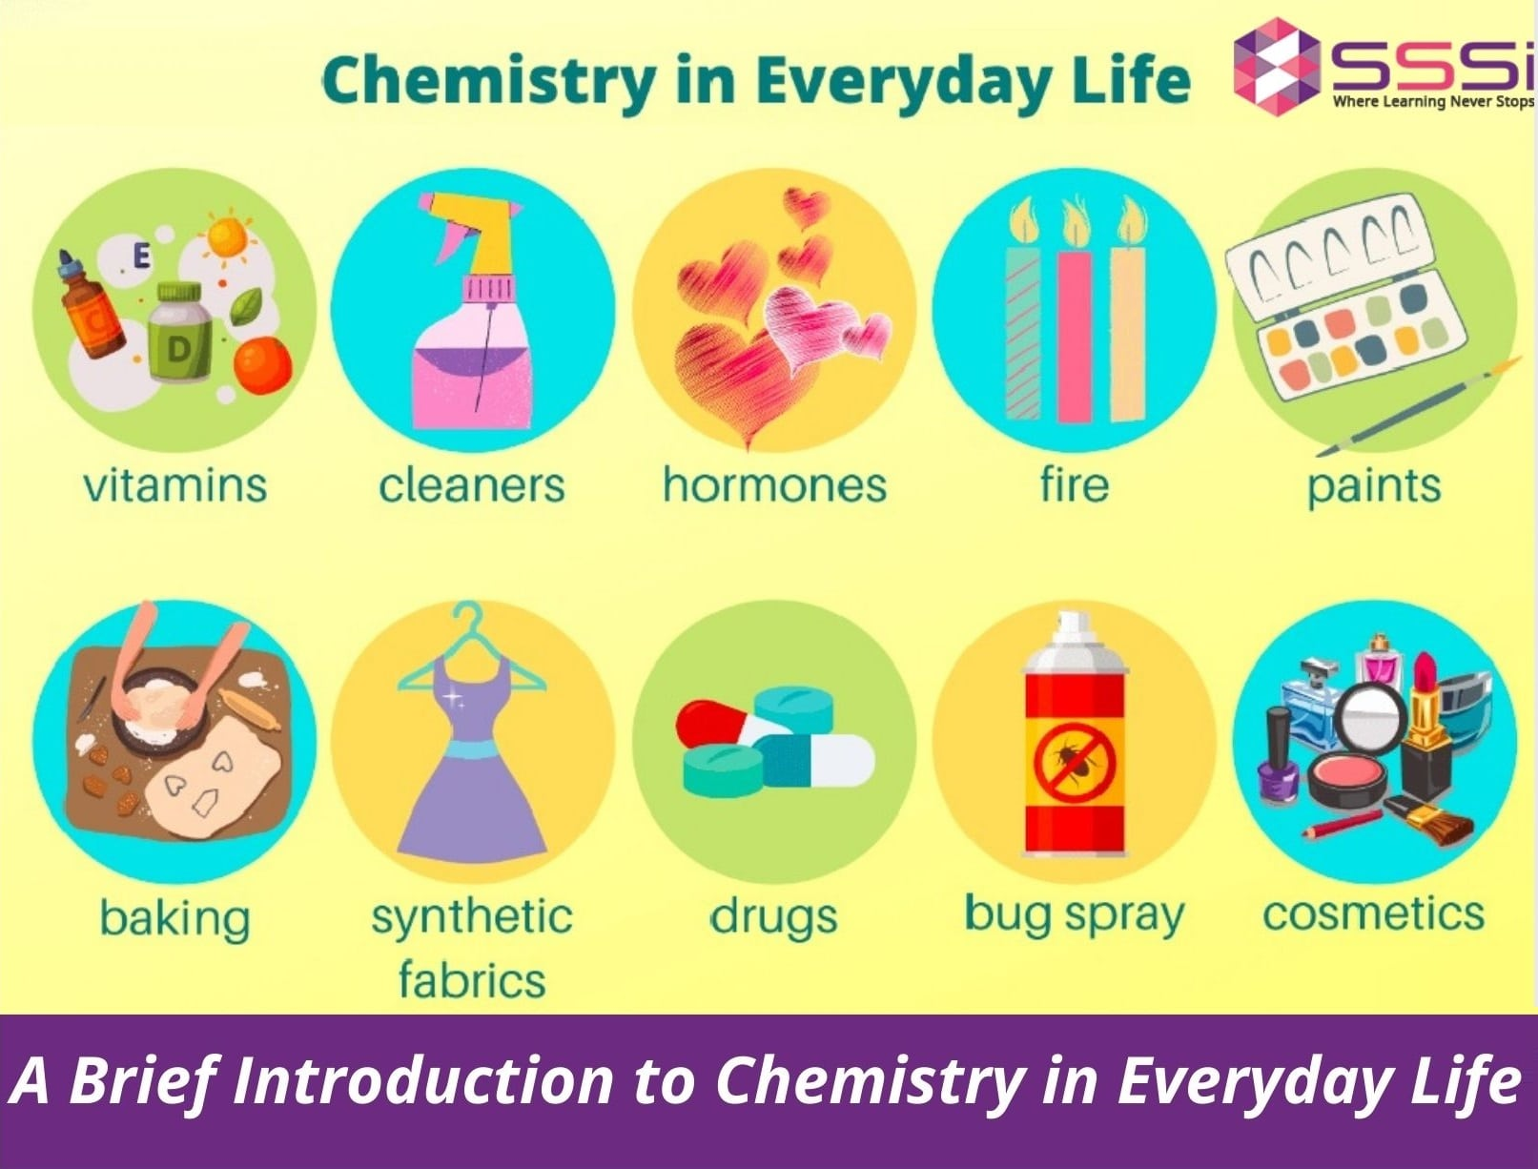**

• Organic Chemistry in Action: When you eat french fries, you are consuming carbohy drates, which are organic molecules. Organic chemists also figure out how to make cooking oils safe and efficient. Also, the medicines you take are created by organic chemists.

• Inorganic Chemistry in Action: The battery in your phone or laptop (a lithium-ion battery) is a wonderful example of inorganic chemistry at work.

• Analytical Chemistry in Action: Have you seen crime shows where tiny samples are analyzed? That’s forensic analytical chemistry, used to identify substances like drugs or blood.

• Physical Chemistry in Action: The battery in your car works because of physical chemistry rules related to electricity and chemical changes.

• Environmental Chemistry in Action: Cleaning our drinking water using filters and special chemicals to remove dirt and germs is a key task of environmental chemistry.

**1.5. The Dream Team: Science, Technology, and Engineering**

• Science: This is about understanding how the natural world operates. It answers the "why" and "how" questions. For example, *Why* does iron rust?

• Technology: This is about applying what we learn from science to create useful tools, machines, or methods. It takes the "why" and turns it into a "how to build it." For example, *How* can we make a coating that stops rust?

• Engineering: This involves designing and building practical solutions. Engineers use scientific knowledge and technological tools to turn ideas into real-world items. For example, a chemical engineer designs the *process* for making an anti-rust coating in a factory.

**1.6. Applications Of Science And Technology And Engineering**

Examples of the Team Working Together

• Stopping Rust:

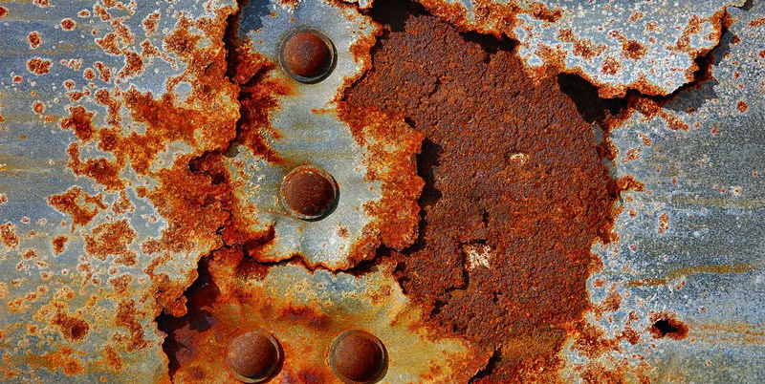

– Science: We learn that iron, water, and oxygen react together to form rust. – Technology: We develop special paints or coatings that can block water and oxygen from reaching the iron.

– Engineering: Engineers design the factories and systems to produce these rust-proof coatings and apply them to things like cars or bridges.

• Using Solar Energy:

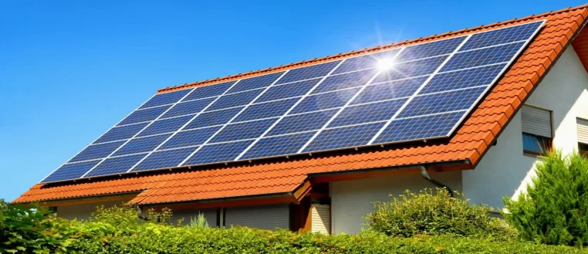

– Science: Scientists discover that certain materials, like silicon, can turn sunlight directly into electricity.

– Technology: We create solar panels that use these special materials. – Engineering: Electrical engineers design how to connect many solar panels to power homes or even whole cities. Civil engineers design the structures that hold these panels safely.

• Cleaning Water:

– Science: We study the chemicals and germs that make water unsafe.

– Technology: We develop filters and chemical treatments to remove these harmful substances.

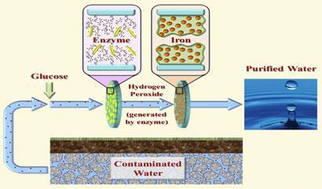

– Engineering: Chemical engineers design complete water treatment plants. They figure out the best steps, like settling, filtering, and adding chemicals, to make water safe to drink.

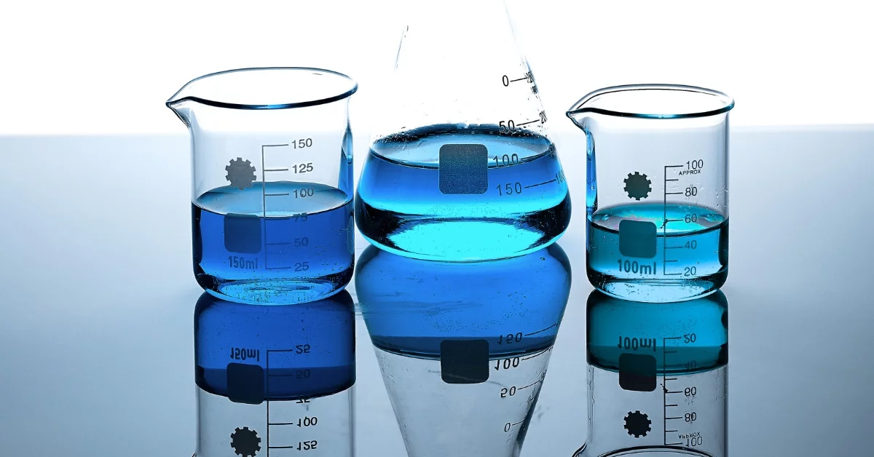

• Making Plastic Bags:

– Science: Scientists discover how tiny molecules called "monomers" can link together to form long, strong chains called "polymers." Polyethylene, which is plastic, is one such polymer.

– Technology/Engineering: Using this knowledge, engineers design machines that can take these polymers and shape them into thin, useful plastic bags.

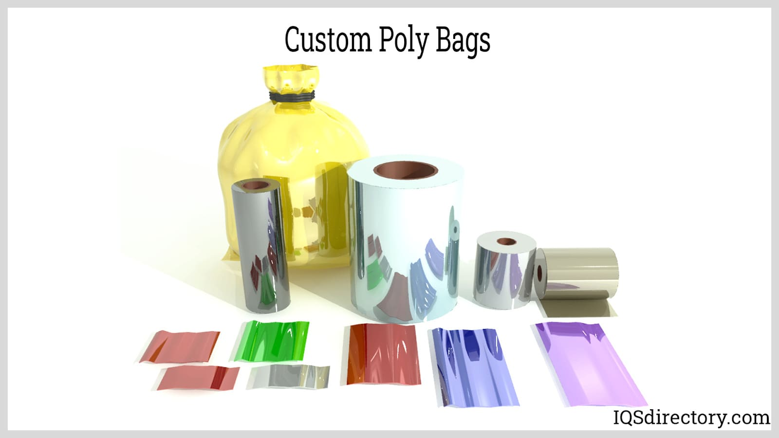

So, whenever you see something new or amazing in the world, it’s likely that science helped us understand it, technology helped us create the tools, and engineering helped us build and put it into use! These three fields are always connected and push our world forward.



